Project Design Phase-2

Data Flow Diagram & User Stories

|  |  |
| --- | --- |
| **Team ID** | **PNT2022TMID11779** |
| **Project Name** | **IoT based smart crop protection system for agriculture** |

DATA FLOW DIAGRAM:

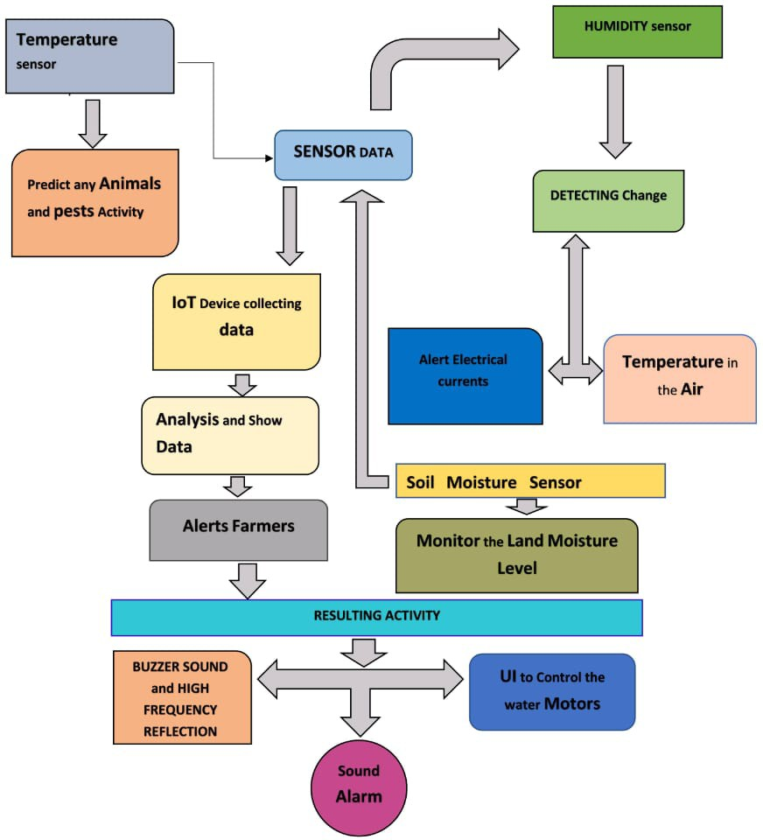

|  |  |  |  |  |  |  |
| --- | --- | --- | --- | --- | --- | --- |
| **User Type** | **Functional requirement (Epic)** | **User Story numbe**  **r** | **User Story/Task** | **Acceptancecr iteria** | **Priority** | **Release** |
| **Customer (Mobile user)** | **Registration** | **USN-1** | **User can enter into the web application** | **I can access my account**  **/dashboard** | **High** | **Sprint 1** |
|  |  | **USN-2** | **User can register their**  **credentials like email id and password** | **Ican receive**  **confirmation email & click confirm** | **High** | **Sprint 1** |
|  | **Login** | **USN-3** | **User can log into the**  **application by entering email & password** | **I can login to**  **my account** | **High** | **Sprint 1** |
|  | **Dashboard** | **USN-4** | **User can view the**  **temperature** | **I can view**  **the data given by the device** | **High** | **Sprint 2** |
|  |  | **USN-5** | **User can view the**  **level of sensor monitoring value** | **I can view**  **the data given by the device** | **High** | **Sprint 2** |
| **Customer**  **(Web user)** | **Usage** | **USN-1** | **User can view the**  **web ppage and get the information** | **I can view**  **the data given by the device** | **High** | **Sprint 3** |
| **Customer** | **Working** | **USN-1** | **User act according to**  **the alert given by the device** | **I can get the**  **data work according to it** | **High** | **Sprint 3** |
|  |  | **USN-2** | **User turns ON the**  **water motors/Buzzer/Sound Alarm when occur the disturbance on field.** | **I can get the**  **data work according to it** |  | **Sprint 4** |
| **Customer**  **care Executive** | **Action** | **USN-1** | **User solve the**  **problem when some faces any usage issues** | **Ican solve**  **the issues when some one fails to understandin g the procedure** | **High** | **Sprint 4** |
| **Administr**  **ation** | **Administratio**  **n** | **USN-1** | **User store every**  **information** | **I can store**  **the gained information** | **High** | **Sprint 4** |